**Objective:**

* Install Python and its libraries for executing the modules.

**Pre-Requisites:**

* Container should be running.
* Root user access.

**Steps:**

* Login to the instance as root user < docker exec -u 0 -it mycontainer bash >
* Update sudo installer (if sudo is not available then cat > /etc/suoers and add the line ‘user ALL=(ALL) ALL’)
* Update /etc/apt/sources.list with

deb http://deb.debian.org/debian stretch main

deb-src http://deb.debian.org/debian stretch main

* apt-get install sudo -y
* Follow these steps to install python in the linux instance

<https://linuxize.com/post/how-to-install-python-3-8-on-debian-10/>

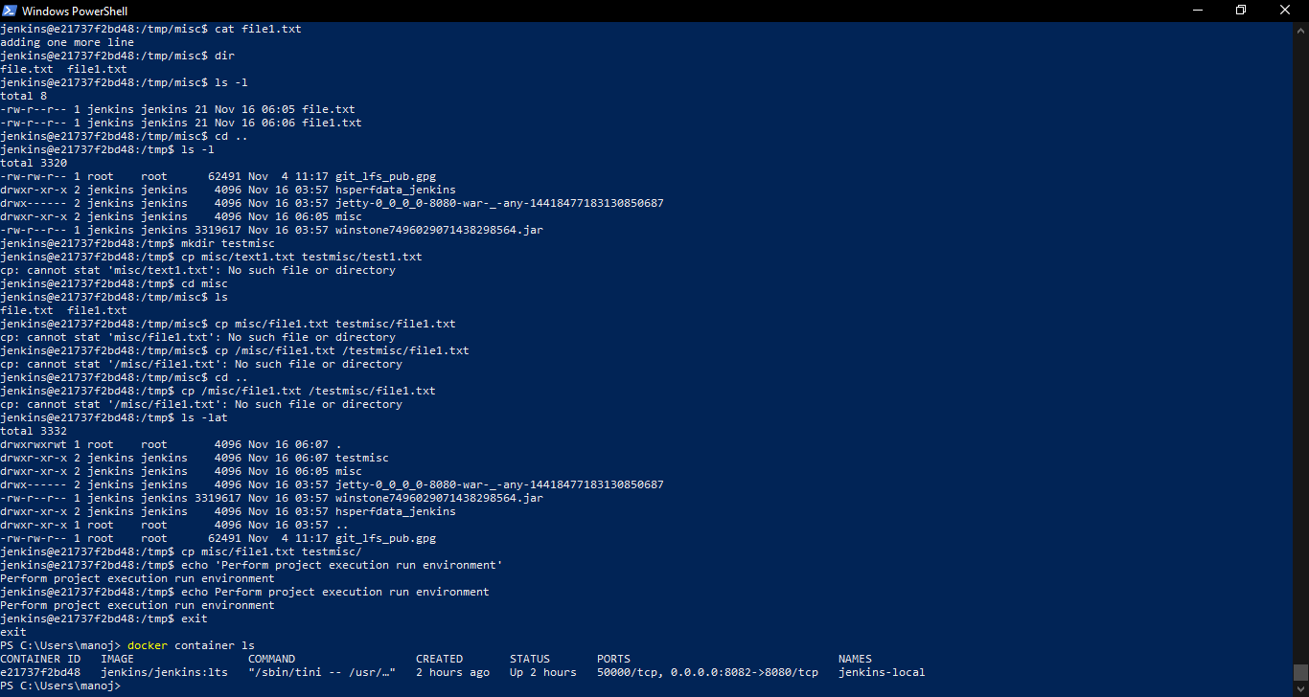

root@e21737f2bd48:/# whereis python3.8

python3: /usr/local/bin/python3.8 /usr/local/bin/python3.8-config /usr/local/lib/python3.8